Data Pipeline Sanity Checks

INDEX / TABLE OF CONTENTS

1.Data Pipeline Sanity Checks
2.Volume & Completeness Validation
3.Schema Integrity & Data Type Validation
4.Uniqueness & Deduplication
5.Business Logic & Data Reconciliation
6.Data Freshness Validation
7.Pipeline Verification Queries

Overview: Data Pipeline Sanity Checks:
Data pipeline sanity checks are quick, automatic health checks you run after deploying your project. They make sure your data is correct, complete, and moving safely through every step of your pipeline—from Google Pub/Sub and Cloud Storage to Cloud Spanner and Big Query.
Instead of testing every single line of code, sanity checks focus on the most important basics. They quickly catch big issues like missing data, duplicate records, broken formats, or stuck pipelines before bad data reaches end-users or dashboard reports.

Core Pillars of Pipeline Sanity Validation

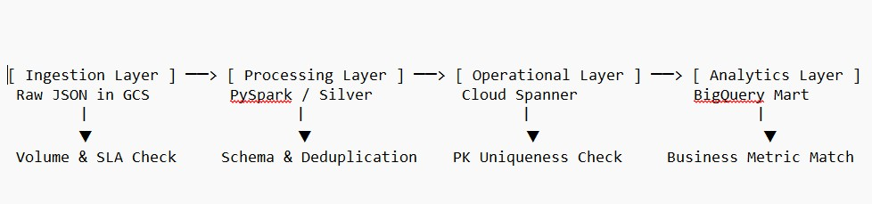
Core Pillars & Test Specifications
- Volume & Completeness Validation
  - Purpose: Ensures raw records are landing continuously without silent drops, partial batch loads, or empty upstream extractions.
  - Specific Tests Executed:
    - Zero-Row Check: Confirms upstream jobs processed records and target tables are populated (COUNT(*) > 0).
    - Row Count Reconciliation: Verifies record count parity across processing layers (e.g., PySpark cleaned records vs. Cloud Spanner inserts).
    - Null Value Audit: Validates that mandatory business keys (order_id, product_id, order_date) contain zero NULL entries.

- Schema Integrity & Data Type Safety
  - Purpose: Guarantees structural correctness, confirming numeric fields and dates parse accurately without unhandled exceptions.
  - Specific Tests Executed:
    - Type Casting Check: Verifies numeric attributes like quantity cast correctly as integers rather than string primitives.
    - Timestamp Format Check: Confirms date fields parse to valid UTC ISO timestamps (YYYY-MM-DD HH:MM:SS) without falling back to epoch defaults (1970-01-01).
    - Schema Evolution Check: Ensures upstream field additions do not break downstream writes or federated reads.
- Uniqueness & Deduplication (Idempotency)
  - Purpose: Validates that streaming re-runs or duplicate message arrivals do not create duplicate line items in downstream layers.
  - Specific Tests Executed:
    - Primary Key Constraint Check: Ensures composite key pairs (order_id + product_id) maintain 100% uniqueness with zero duplicates (HAVING COUNT(*) > 1 yields 0 rows).
    - Idempotency Check: Confirms re-running PySpark or BigQuery jobs updates existing records instead of creating duplicate entries.
- Business Logic & Data Reconciliation
  - Purpose: Confirms mathematical consistency and rule enforcement across distinct database engines (OLTP vs. OLAP).
  - Specific Tests Executed:
    - Range Checks: Verifies metric values align with business logic (e.g., quantity > 0).
    - Aggregation Accuracy: Reconciles metrics between layers—ensuring SUM(quantity) in Cloud Spanner matches SUM(total_items_sold) in the BigQuery summary mart.
- Pipeline SLA & Data Freshness
  - Purpose: Detects frozen scheduled queries, stale caches, or upstream pipeline latency before business decision-makers view outdated figures.
  - Specific Tests Executed:
    - Data Freshness Check: Evaluates MAX(aggregated_at) against
CURRENT_TIMESTAMP() to detect delays exceeding the 24-hour SLA.
    - Connectivity & Zero-ETL Handshake: Confirms BigQuery queries live Cloud Spanner records via federated EXTERNAL_QUERY without IAM or network timeout errors.

1. Volume Check: Did any data actually land?
Tests if Spanner received rows and if your BigQuery summary table has data.
-- Check 1A: Count total rows in Spanner
SELECT COUNT(*) AS spanner_row_count
FROM EXTERNAL_QUERY(
"projects/snappy-mapper-498509-e0/locations/asiasouth1/connections/spanner-ecom-conn",
"SELECT order_id FROM EcomOrders"
);

-- Check 1B: Count total rows in the BigQuery summary table
SELECT COUNT(*) AS bq_summary_row_count
FROM `snappy-mapper-498509-
e0.ecom_analytics.daily_product_summary`;

Completeness Check: Are there any missing key values?
Ensures critical fields like order_id or product_id aren't coming through as empty (NULL).
SELECT
COUNTIF(order_id IS NULL) AS missing_order_ids,
COUNTIF(product_id IS NULL) AS missing_product_ids,
COUNTIF(quantity IS NULL) AS missing_quantities
FROM EXTERNAL_QUERY(
"projects/snappy-mapper-498509-e0/locations/asiasouth1/connections/spanner-ecom-conn",
"SELECT order_id, product_id, quantity FROM EcomOrders" );

Uniqueness Check: Are there duplicate orders?
Checks if PySpark deduplication worked so primary key pairs (order_id + product_id) aren't repeated.
SELECT order_id, product_id,
COUNT(*) AS duplicate_count
FROM EXTERNAL_QUERY(
"projects/snappy-mapper-498509-e0/locations/asiasouth1/connections/spanner-ecom-conn",
"SELECT order_id, product_id FROM EcomOrders"
)
GROUP BY order_id, product_id
HAVING COUNT(*) > 1;

4. Business Logic Check: Do the numbers make sense?
Ensures metric values aren't zero or negative, and checks if totals match across databases.

-- Check 4A: Look for bad quantities (<= 0)
SELECT COUNT(*) AS bad_quantity_rows
FROM EXTERNAL_QUERY(
"projects/snappy-mapper-498509-e0/locations/asiasouth1/connections/spanner-ecom-conn",
"SELECT quantity FROM EcomOrders WHERE quantity <= 0"
);

-- Check 4B: Total items sold in Spanner vs BigQuery
(Reconciliation)
SELECT
(SELECT SUM(quantity) FROM EXTERNAL_QUERY(
"projects/snappy-mapper-498509-e0/locations/asiasouth1/connections/spanner-ecom-conn", "SELECT quantity FROM EcomOrders"
)) AS total_units_in_spanner,

(SELECT SUM(total_items_sold)
FROM `snappy-mapper-498509e0.ecom_analytics.daily_product_summary`
) AS total_units_in_bigquery;

Data Freshness Check: When was the pipeline last updated?
Checks the newest timestamp in your analytical data mart to ensure the schedule isn't frozen.

SELECT
MAX(aggregated_at) AS newest_data_time,
CURRENT_TIMESTAMP() AS current_time
FROM `snappy-mapper-498509e0.ecom_analytics.daily_product_summary`;

